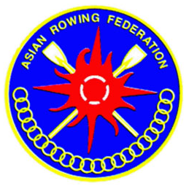
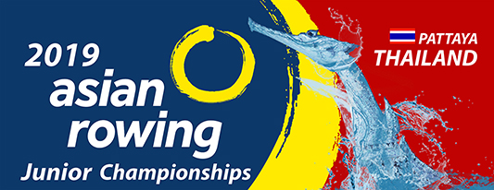

2019 Asian Rowing
Junior Championships

Pattaya, Thailand

18th- 22nd December 2019

Bulletin -2

Asian Rowing Federation
President: Admiral Chainarong Charoenruk
Vice-Presidents: Mr. Nicholas Ee
Mrs. Ho Kim Fai
Mr. Yong Nam Jin
Mr. Vahid Moradi
Mr. Duan Xuan
Secretary-General : RAdm.Praparnpongs Pochanasomburana
Executive Director : Ms. Meng Yaning (Flora),
Committee Chairs:
Events Committee : Mr. Edy Suyono
Umpiring Committee : Mr. Takao Senda
Competitive Committee : Mr. Chris Perry
Marketing & Promotion Committee : Capt. Jirames Wongsanittadech
Rowing Development Committee : Mr. Hassan Ahmad Bilal
Para Rowing Committee : Mr. Seung-Hoon HAN
Rowing for all Committee : Mr. Girish J Phadnis
Sports Medicine Committee : Mr. Mikio Hiura
Tel: +66 2170 9235 Fax: +66 2170 9236
E-mail: office@arfrowing.com (Thailand)
office_arf@sports.cn (Ms. Meng Yaning (Flora), Executive Director
Website: www.arfrowing.com

Rowing Canoeing Association of Thailand
President: Adm. Chainarong Charoenruk
Secretary: RAdm. Narupol Kirdnak
Address: The Rowing and Canoeing Association of Thailand (R.C.A.T.)
18th Floor, Chalearmprakeat Building,
286 Sport Authority of Thailand Ramkhamhang rd.
Huamak, Bangkapi, Bangkok 10240
Tel: +66 2170 9235
Fax: +66 2170 9236
E-mail: office@rcat.or.th
Website: www.rcat.or.th

Organizing Committee
Chairman :RAdm. Narupol Kirdnak
Vice Chairman :Capt.Wiwat Kwansungnern,
:Capt. Poollap Tattatongkam
Venue Manager :Capt. Norrapat Ta-In
Competition Manager :Dr. Rangsan Wongsan
Technical affairs :Dr.Tanormsak Sanakham
General affairs :Capt. Nopparote Siripariyapong
Transportation/ Logistic :Capt. Nopporn Theptoranee
Secretary (Contact Person) :Capt. Jirames Wongsanittadech(+66 97 946 3592)
Deputy Secretary (Contact Person) :Cdr. Preecha Phuangphairote (+66 816165684)
E-mail: office@rcat.or.th, tukky1972@gmail.com, phuang_009@hotmail.com,
International Jury
The International Jury will be appointed by the ARF Umpires Committee.

- General Introduction of Pattaya, Thailand:

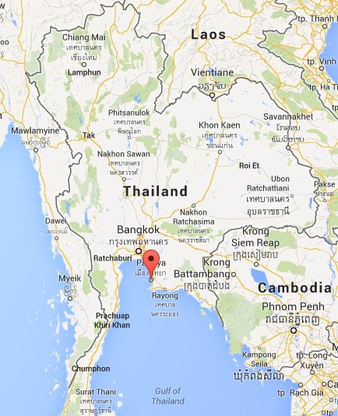
Pattaya is a city in Thailand, a beach resort popular with tourists and expatriates. It is located on the east coast of the Gulf of Thailand, about 165 km southeast of Bangkok within but not part of Amphoe Bang Lamung (Banglamung) in the province of Chonburi.
Just over one hour from Bangkok’s Suvarnabhumi Airport, Pattaya is a lively beach town that draws visitors from around the world. With activities that include a wide array of water sports, golf, shopping, cabaret shows, an elephant village, and fascinating museums, it’s impossible not to have an action-packed Pattaya holiday. Pattaya is certainly a Thai beach resort that meets the needs of any visitor on any budget.

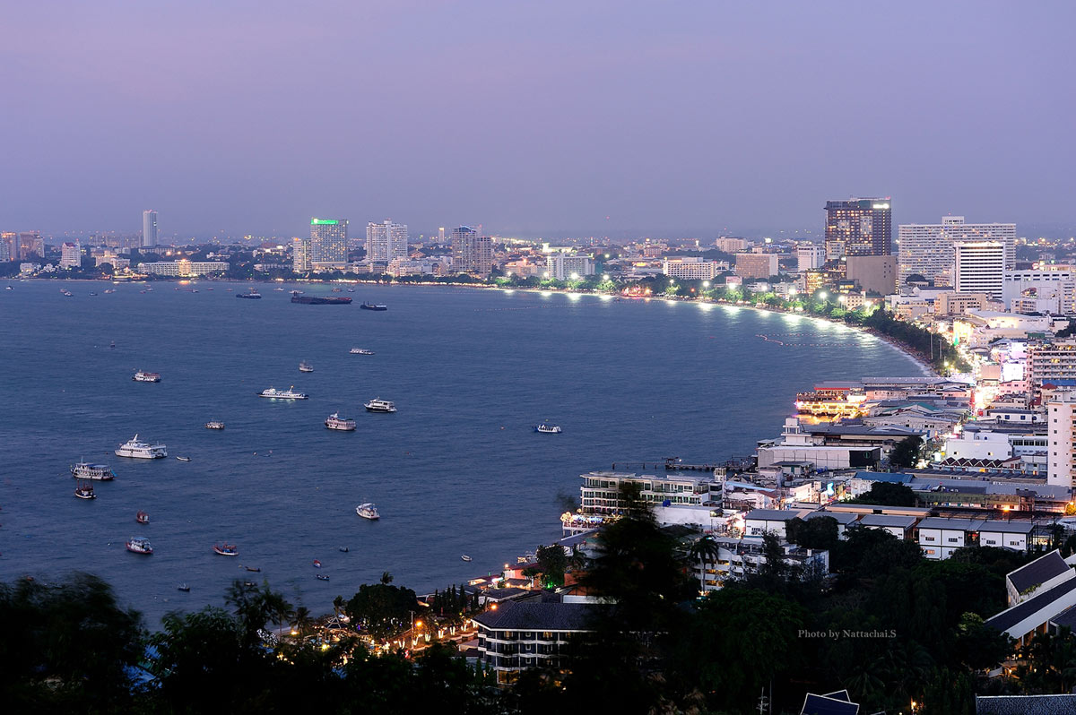

Competition Information:
2.1 Date: 18th to 22nd December 2019
2.2 Competition Venue: The Asian Rowing Junior Championship will be held in the water sport training centre at “BangPhai reservoir”
2.3 Provisional Programme:

Schedule
 | 14 Sat | 15 Sun | 16 Mon | 17 Tue | 18 Wed | 19 Thu | 20 Fri | 21 Sat | 22 Sun | 23 Mon
Arrival | / | /
Boat Rental | / | /
Course Open | / | /
Jury Meeting |  |  |  | /
Team Manager |  |  |  | /
Training |  | / | / | /
Heats Group A |  |  |  |  | /
Heats Group B |  |  |  |  |  | /
Repechages/Semi |  |  |  |  |  |  | /
Final Group A |  |  |  |  |  |  |  | /
Final Group B |  |  |  |  |  |  |  |  | /
Departure |  |  |  |  |  |  |  |  |  | /

2.4 Events:
The Asian Rowing Junior Championship will consist of the following
Events:
Men: JM1X, JM2X, JM2-, JM4X, JM4-, JM8+
Women: JW1X, JW2X, JW2-, JW4X, JW4- JW8+

Event Groupings:
The events will be divided into two Groups, A and B for scheduling purposes. Where the two Groups are run on the same day, they would be held as separate sessions, e.g. Group A in the morning; Group B in the afternoon.

The Groups are as follows:
Group A | Group B
JW1X | JM1X
JM2X | JW2X
JW2- | JM2-
JM4- | JW4-
JW4X | JM4X
JW8+ | JM8+

Teams are strongly advised not to make double-up entries for athletes or crews or share equipment in the same Group. Teams doing so make such entries entirely at their own risk and no changes to the race schedule will be made to accommodate these entries.

2.5 Entries
Final Entry is due by 15th November 2019.
The completed Final Entry must include all necessary information for each crew, including name with date of birth of each athlete, all team members and substitutes and officials.
Entry Forms for Preliminary and Final Entries are attached to this Bulletin. These should be filled in and forwarded to the Organizing Committee, with a copy to ARF headquarters, by the stipulated date.

2.6 Weather
The past average weather conditions in Pattaya in October are as follows:

Average daily maximum air temperature (°C) | 29.6 | Predominant wind direction | 211° SSW
Average daily minimum air temperature (°C) | 24.5 | Average wind speed | 6.8 km/hr
Average relative humidity (%) | 80 | Maximum wind speed | 16.1 km/hr
Average monthly rainfall (mm) | 249.4

- Boats and Equipment
- All boats and other equipment must comply with FISA Rules of Racing.
- Participating teams will be encouraged to bring their own boats and oars if possible. Official boat supplier, Swift Racing, will provide boats for participants if they are unable to bring own material.
- If you do not bring own boats, you should contact Swift Racing for your boat rental by 15th Oct. 2019. Boats and Oars Rental will be only provided to NFs requesting boats and oars rental to Swift Racing. After this date, there is no guarantee of boat availability.
- Contact person : Elaine Chen , E-mail : boatrental@swiftinternational.biz
- The boat rental charges are as follows (USD / during the championships):
Single scull (1x) $400
Double scull / Pair (2x / 2-) $600
Quadruple Scull / Pour(4x/4-) $800
Eight (8+) $1200
- Plese note that all the boat rental must have deposit 100/boat.

Official Shipping Agent
If Nfs want to bring own boats by container, please contact to belows,
Official Freight Forwarder: Ocean Air International Co., Ltd.
Address: 1249/219 Gems Tower 38th Chareonkrung Rd.,Suriyawongse,Bangrak,Bangkok 10500
Contact person: Ms. Sirirat Ratthajorn (Sales Manager)
Email: sirirat@oceanairinter.com
Contact person: Ms. Jidapa Chirapong (Oversea Correspondence)
Email: jidapa@oceanairinter.com
TEL: +66 2267 4949 – 53
FAX: +66 2267 4954 or +66 2266 5554
E-MAIL: jidapa@oceanairinter.com
WEBSITE: www.oceanairinter.com

- Oars rental
Each team is highly recommended to bring their own oars and sculls as the blades of all oars/sculls must be painted on both sides in the colors of the respective Federations.
If you need to rent oars and sculls the rate is $100/pair scull, $120/pair sweep, for the event.

Transportation:
Organizing Committee will arrange the local transportation from the venue to hotel and also turn during the event.
- Suvarnabhumi International Airport and Donmeang International Airport to Ambassador City Pattaya 50 USD/person.(Round trip)
- U-Tapao International Airport to Ambassador City Pattaya 20 USD/person. (Round trip)

Accommodation and Meals:
Ambassador City Pattaya will be the Official Hotel. Bookings should be made through the Organizing Committee by 1st November 2019

6.1 Ocean Wing (Deluxe room)

Single Room | USD 110/person/night including 3meals
Twin-room Sharing | USD 95 /person/night including 3 meals
Triple-room Sharing | USD 80 /person/night including 3 meals

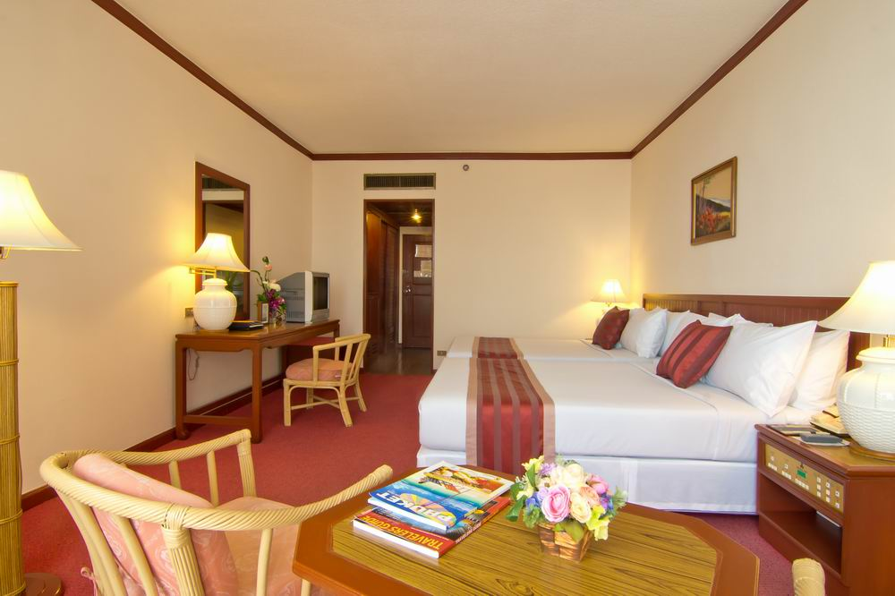
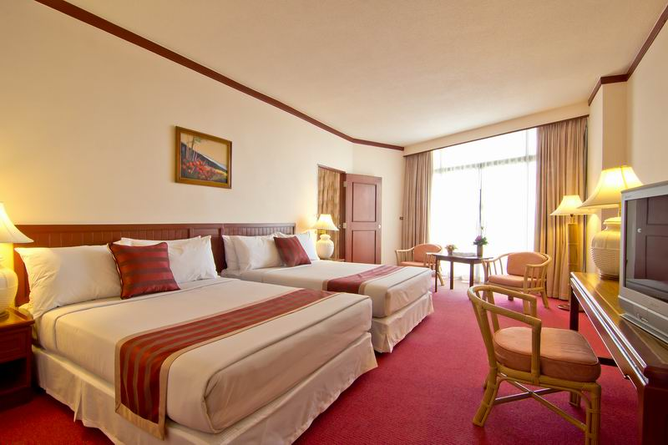

6.2 Tower Wing (Superior room)
Single Room | USD 95/person/night including 3 meals
Twin-room Sharing | USD 80 /person/night including 3 meals
Triple-room Sharing | USD 65 /person/night including 3 meals

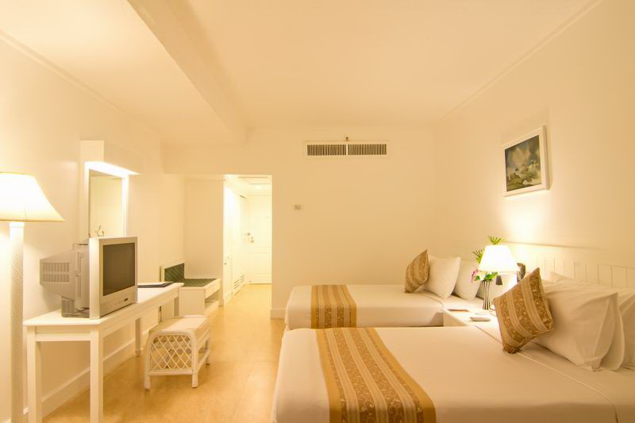
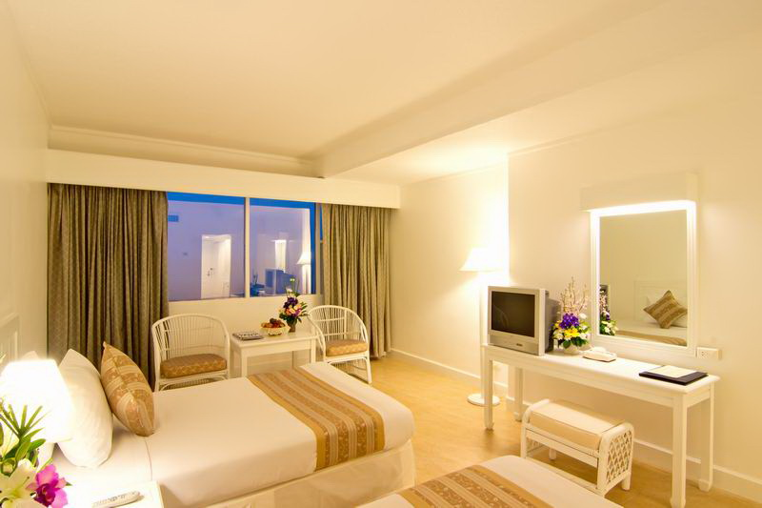

6.3 Garden Wing (Standard room)
Single Room | USD 85/person/night including 3 meals
Twin-room Sharing | USD 70 /person/night including 3 meals
Triple-room Sharing | USD 55 /person/night including 3 meals

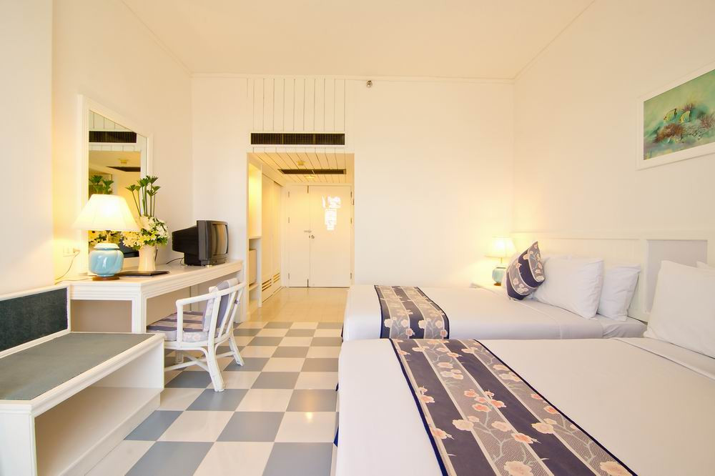
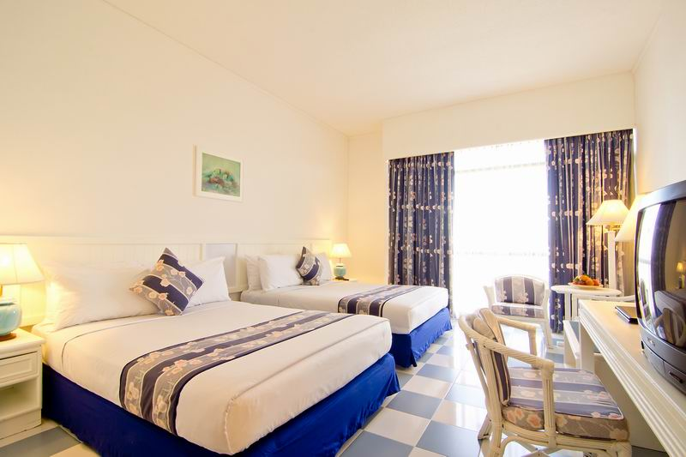

Visas:
- Visitors from a number of Asian countries require visa to enter the Thailand
- Such visas must be issued before travel, Please check to Thailand embassy for requirement visa in embassy.
- If you need Visa Invitation, Please send copy of passport (Clear and colour) and photograph by email as soon as possible.

Accreditation:
All Indivisuals (Jury, Team Officials & Participants)are requested to email a passport photograph with Final Entry Forms.

Organizing Committee:
For all enquiries, submission of entries and other information, please contact the Organizing Committee at the following address:
Secretary (Contact Person) : Capt.Jirames Wongsanittadech
Deputy Secretary (Contact Person) : Lcdr. Preecha Phuangphairote
E-mail: office@rcat.or.th, tukky1972@gmail.com, phuang_009@hotmail.com,

Welcome to Pattaya, Thailand for the 2019 Asian Rowing Junior Championships
Enclosed: Accreditation Form – Athletes Deadline: 1st November 2019
Accreditation Form – Officials Deadline: 1st November 2019
Hotel Reservation Form Deadline: 1st November 2019
Entry Form (Adaptive Event)
Final Entry Form by Name Deadline: 15th November 2019
Final Entry Form by Boat & Oars Deadline: 15th November 2019
Arrival & Departure Form Deadline: 15th November 2019

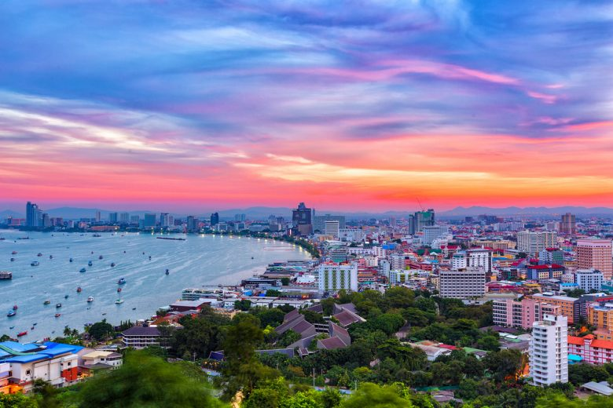

Partners of Asian Rowing Federation

